The Industry Award – Silver Cup – from ComSoc Industry Community Board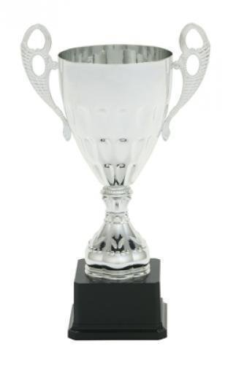
Engraving on the base plates:
IEEE GLOBECOM - right
Industry Forum - left
Most Popular – front
2016 - back

Date of request: 11/15/2016
Date of delivery: 12/03/2016
Deliver to: Washington Hilton, 1919 Connecticut Avenue, NW, D.C. for guest Dr. Narisa Chu
Customer: Dr. Narisa Chu, Mobile: 818-448-8094, Email: narisa.chu@ieee.org

