LCDR Adam Samuels
Request six brass plaques by 22NOV2016.
757-818-3641 (cell); 202-433-5367 (w); samuels7995@gmail.com

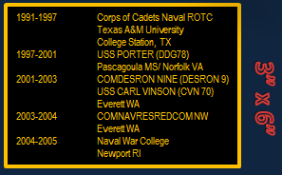

3" tall x 6" wide Black Plate with Gold border and letters
---------------------------------------
1991-1997 Corps of Cadets Naval ROTC
Texas A&M University
College Station, TX
1997-2001 USS PORTER (DDG78)
Pascagoula MS/ Norfolk VA
2001-2003 COMDESRON NINE (DESRON 9)
USS CARL VINSON (CVN 70)
Everett WA
2003-2004 COMNAVRESREDCOM NW
Everett WA
2004-2005 United States Naval War College
Newport RI

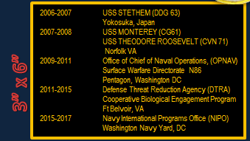
3" tall x 6" wide Black Plate with Gold border and letters
---------------------------------------
2006-2007 USS STETHEM (DDG 63)
Yokosuka, Japan
2007-2008 USS MONTEREY (CG61)
USS THEODORE ROOSEVELT (CVN 71)
Norfolk VA
2009-2011 Office of Chief of Naval Operations, (OPNAV)
Surface Warfare Directorate N86
Pentagon, Washington DC
2011-2015 Defense Threat Reduction Agency (DTRA)
Cooperative Biological Engagement Program
Ft Belvoir, VA
2015-2017 Navy International Programs Office (NIPO)
Washington Navy Yard, DC

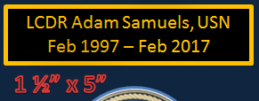
1.5" tall x 5" wide Black Plate with Gold border and letters
---------------------------------------
LCDR Adam Samuels, USN
Feb 1997 – Feb 2017

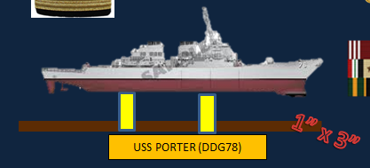
1" tall x 3" wide Gold Plate with Black letters
---------------------------------------
USS PORTER (DDG 78)
---------------------------------------
USS MONTEREY (CG 61)
---------------------------------------
USS STETHEM (DDG 63)

