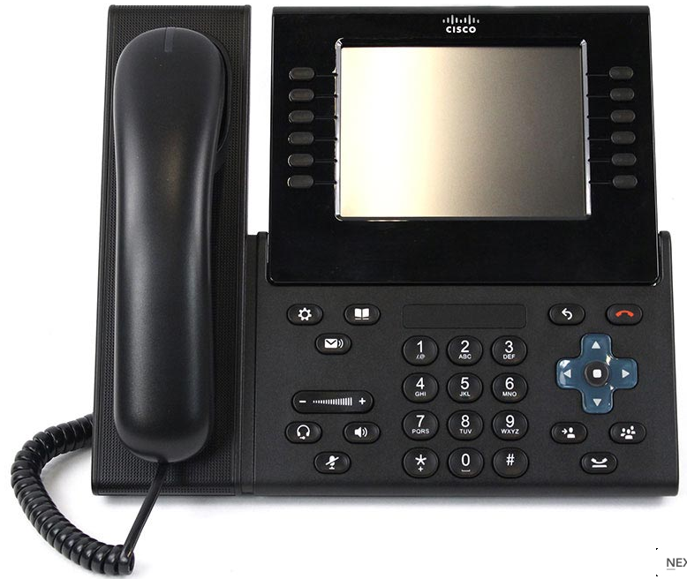

15”

NCOIC SFC Stewart, Domonick

ANCOIC MSgt Bouker, Christopher

SFC DeFreitas, Stephen SSG McClure, Corey

IT1 Hopkins, Jonathan SSgt Orlando, Paul

SGT Hodges, Christopher SPC Lopez, Francisco

Mr. Cannon, Jerry Mr. Hawkins, Leonard

Mr. Cooper, Arthur Mr. Burns, Albert

Mr. Coyne, James Mr. Ocampo, Roland Mr. Taylor, Robert

"What Do You Know About Audio?"

Specialist Ivancso, Benjamin D.

Thank you for all of your efforts while serving as a System Administrator for WHCATel from 04 APR 2013 – 19 MAY 2017 from the members of the White House Communications Agency Telecommunications Division

12”

4 7/16”

NCOIC SFC Stewart, Domonick

ANCOIC MSgt Bouker, Christopher

SFC DeFreitas, Stephen SSG McClure, Corey

IT1 Hopkins, Jonathan SSgt Orlando, Paul

SGT Hodges, Christopher SPC Lopez, Francisco

Mr. Cannon, Jerry Mr. Hawkins, Leonard Mr. Cooper, Arthur Mr. Burns, Albert

Mr. Coyne, James Mr. Ocampo, Roland Mr. Taylor, Robert

"What Do You Know About Audio?"

4”

3 5/16”

4 15/16”

Specialist Ivancso, Benjamin D.

Thank you for all of your efforts while serving as a System Administrator for WHCATel from 04 APR 2013 – 19 MAY 2017 from the members of the White House Communications Agency Telecommunications Division